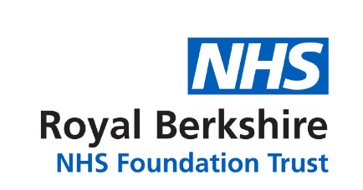

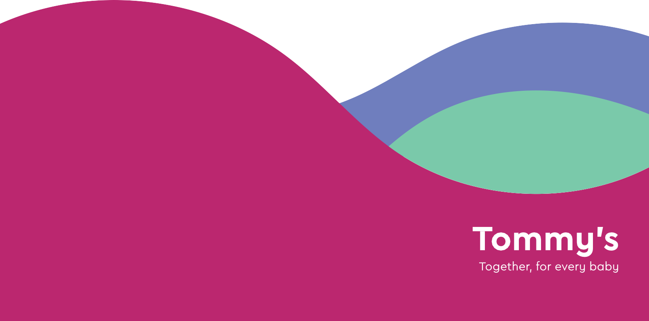

Please speak to your Rainbow Clinic midwife or doctor for further details.

**tommys.org**

Tommy’s is registered charity no 1060508 and SC039280

The Tommy’s National Rainbow Clinic Study, Information Poster | Version 1.0 | 5th December IRAS 249991.

This hospital is currently taking part in the Tommy’s National Rainbow Clinic Study

As a patient attending this clinic you will be asked to take part in this national evaluation project