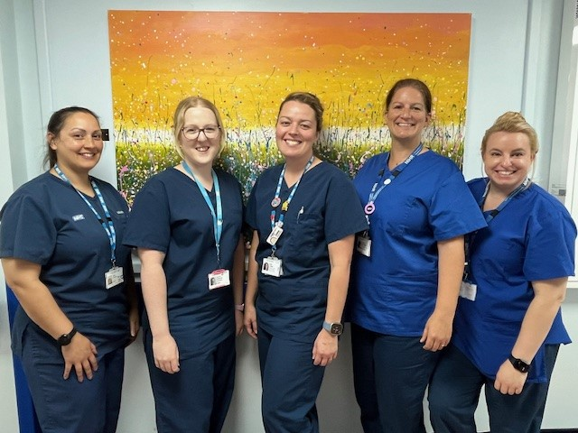

From Left to Right: Anna (Research Midwife), Hayley (Research Midwife), Emma (Team Lead and Research Nurse), Ellie (Research Nurse) and Annie (Research Nurse)

Hello, we are the Women and Children’s Research Team!   
We are a team made up of Midwives and Children’s Nurses who all have a passion for research. You may see us in Antenatal Clinic, the scan department or on Marsh and Iffley Wards when you visit the hospital during your pregnancy. As someone being cared for at the hospital, you may be approached about one of our current maternity studies. We have studies looking into preventing pre-eclampsia in pregnancy, rainbow care after a pregnancy loss, postnatal blood pressure management as well as several other topics. Some of our studies do not require anything from you other than your consent to look at your medical records, some involve taking medication and others may require an interview with you. If you see us around in the maternity department, please say hello and feel free to ask us about research.