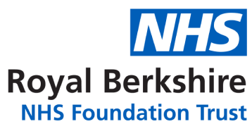

Register of Directors

The following is the current register of Directors of the Royal Berkshire NHS Foundation Trust.

Name | Designation | Date Appointed
Mr. Graham Sims | Chair | August 2015
Mr. Steve McManus | Chief Executive | January 2017
Ms. Katie Prichard-Thomas | Chief Nursing Officer | November 2023
Mr. Don Fairley | Chief People Officer | May 2016
Dr. Janet Lippett | Chief Medical Officer | October 2022
Mr. Dom Hardy | Chief Operating Officer | December 2019
Ms. Nicky Lloyd | Chief Finance Officer | January 2019
Ms. Parveen Yaqoob | Non-Executive Director | January 2023
Ms. Priya Hunt | Non-Executive Director | October 2021
Mr Mike O’Donovan | Non-Executive Director | November 2023
Ms. Helen Mackenzie | Non-Executive Director | January 2019
Dr Bal Bahia | Non-Executive Director | April 2019
Mr. Mike McEnaney | Non-Executive Director | October 2023
Catherine McLaughlin | Non-Executive Director | July 2024
Andrew Statham | Chief Strategy Officer | July 2024
Dr. Minoo Irani | Non-Executive Director | September 2024

September 2024

