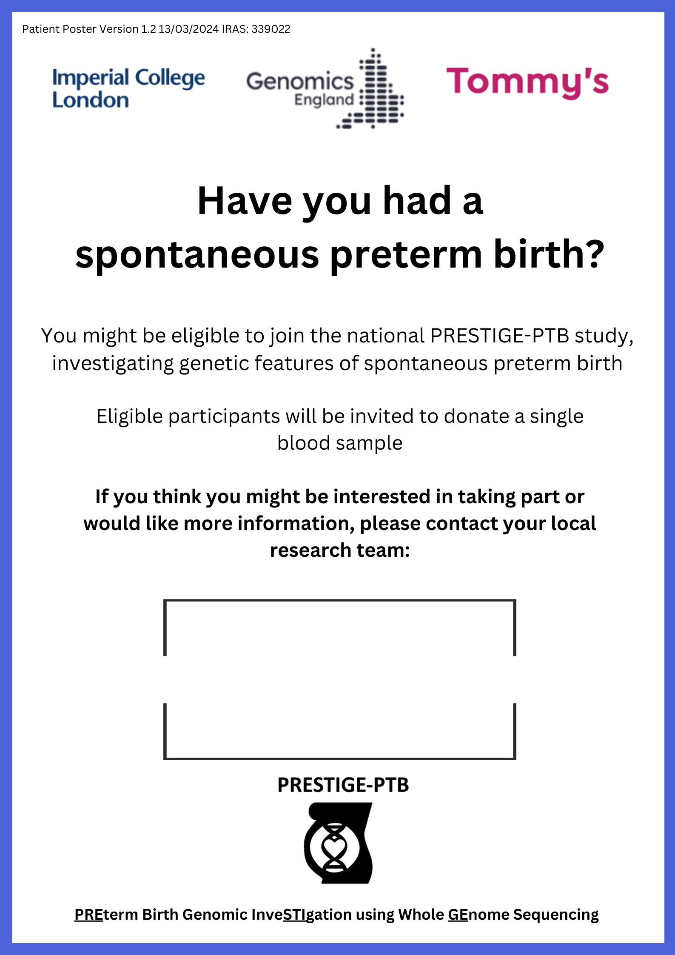

**Ellie** or **Annie** on **0118 322 8652**

**Women.research@royalberkshire.nhs.uk**

Or

Pop in to see us in our office on Level 6, Buscot Ward.