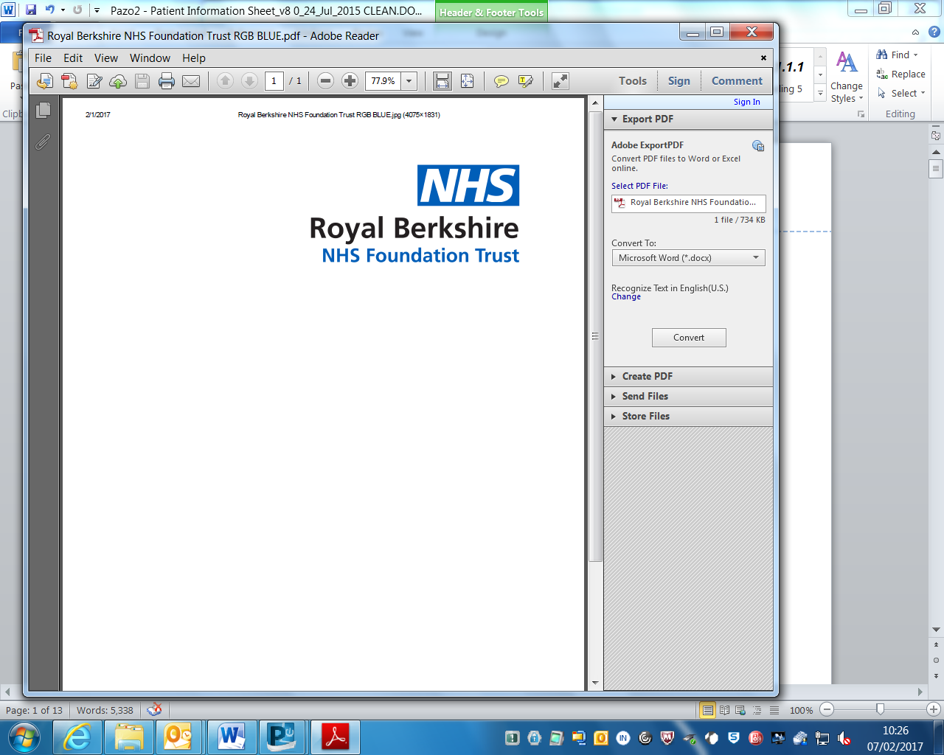

***Calcium supplementation for women at high-risk of pre-eclampsia (CaPE Trial)***

### **ARE YOU AT RISK OF DEVELOPING PRE-ECLAMPSIA?**

**Pre-eclampsia affects 1 in 30 pregnant women in the UK. It usually presents with high blood pressure and protein in the urine but may affect other organs in the body, and the baby.**

**Your care team will be able to tell you if you are at risk of developing pre-eclampsia.**

**CaPE is a research study looking to find out if calcium supplements taken during pregnancy reduce the chances of developing pre-eclampsia.**

**We want to recruit 7756 pregnant women at risk of pre-eclampsia from across the UK – could you be one of them?**

|  |
| --- |
| **For more information about the CaPE trial, scan the QR code or visit** [www.birmingham.ac.uk/CaPE](http://www.birmingham.ac.uk/CaPE) |
| **If you are interested in taking part in CaPE, talk to your midwife, doctor or the local research team:** |
| **Contact name:** Anna Campbell/Lola Okungade/Hayley Wheeler **Email:** child.research@royalberkshire.nhs.uk  **Tel:** 0118 322 8652 |

This study is funded by the National Institute for Health Research (NIHR) Health Technology Assessment Programme (award number 127325) The views expressed are those of the author(s) and not necessarily those of the NHS, NIHR or the Department of Health and Social Care. This study has been designed in collaboration with Action on Pre-eclampsia Charity.